Check out these 20 skill-building activities to keep busy at home! | Running out of fun and interesting ways to reward your child for positive behavior?  Check out these  100 Free/Inexpensive Rewards for Home | Take a trip to the Bronx Zoo and see the animals!
Try this fun meditation with movement from Smiling Mind! | 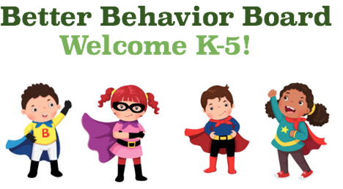 | Want to take a trip to Disney World and go on their rides? You can now ride virtually! Click here
Keep your body moving with  Yoga Ed. Yoga & Mindfulness for Children! | Keep your mind busy with Explore.org. Check out the live cams to learn about animals and places all over the world! | Get creative! Make your own amusement park!

