Visit PBS Music’s Bubble Beats. Can you identify the unique beats?  OR  Follow along with a drawing lesson on the Art for Kids! Hub | Create a Behavior Chart to keep your child motivated to complete their work and stay on schedule. | Challenge yourself by spelling out your name and following the challenges that go along with the spelling.  Spell Your Name Workout
Try one of these 20 Sensory Activities  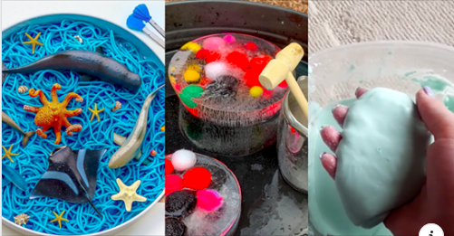  Sensory play is the magic formula for emotional regulation. | 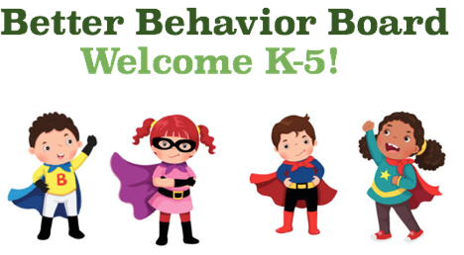 | Want to try yoga with some of your favorite characters from Pokemon, Spiderman, Star Wars, Trolls, and more? Check out  Cosmic Kids Yoga
Create a Zen Zone or Peace Corner in your home. Put together these fun dice to learn things you can do to stay calm and cool.  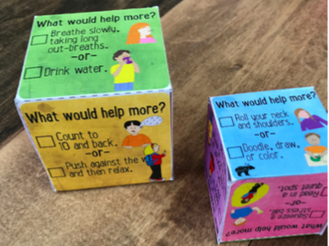 | Relax to one of these  short stories, visualizations, or breathing exercises on  Peace Out - Bedtime FM. | Watch a BrainPop video on emotions. You can choose to write about it, draw about it, or do the activity!
Created by: Colleen Belmonte & Jessica D’Orazio

