Listen to a short relaxation story inspired by superheroes! We’ll stretch, breathe, and talk about how we can be everyday superheroes. | Still struggling to find a schedule that works for you and your child?  Take a look at these  33 Visual Picture Schedules | Missing your friends and family? Make a Flip Grid to say hello, have a dance party, and/or display crafts you created!
Get your imagination fired up!  Learn how to draw your favorite characters with Steve Harpster on YouTube! | 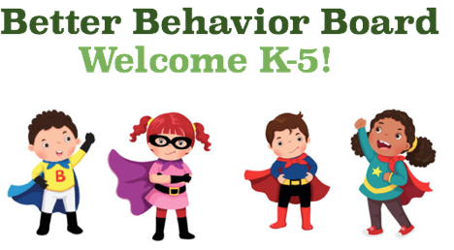 | Check out Pure Edge for Mindful Movement videos and activities, reflection journals, and a mindfulness curriculum.To access,click download under free content to share.
Keep your body moving with  Joe the Body Coach!  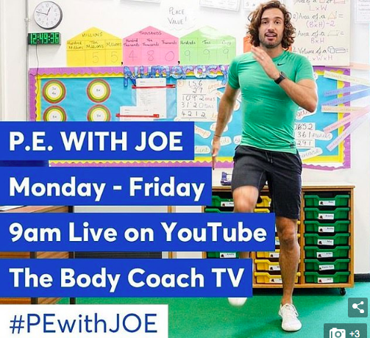 | Keep your mind busy with Science Mom’s and Math Dad’s fun challenges, games, and crafts.  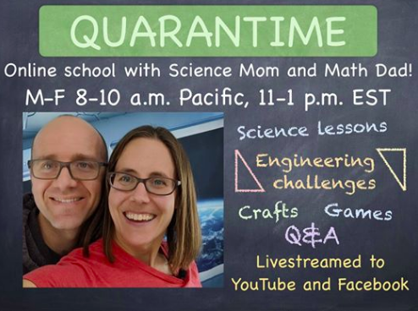 | Join a Comic Contest or Virtual Book Fest while engaging in weekly projects on  Scholastic at Home

